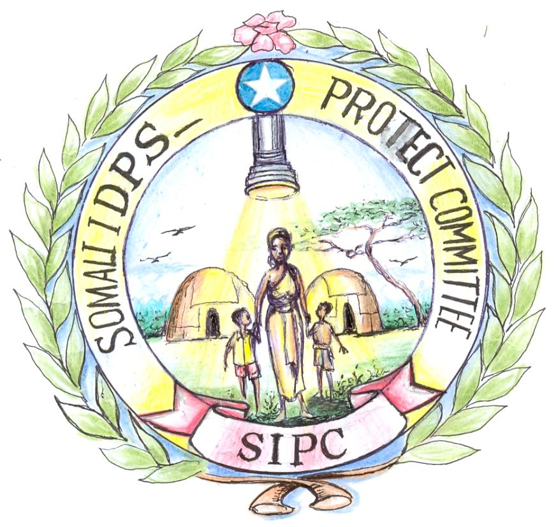
Somali IDPs Protect
Committee
(SIPC)
Guddiga u Dooda
Xuquuqda
Barakacayaasha Soomaaliyeed

South and Central Somalia
Headquarters Mogadishu – Somalia

. Ref: 0894/SIPC/2010 Date: 07-11-2010

To Glamour Magazine

CC All International News Agencies

Subject Accusation towards Drs Hawa and Drs Amina

Dear Colleagues,

“There is no greatness where simplicity, truth and virtue are absent”, we are giving you this expression as we have already met Drs. Hawa and Her Daughter Drs. Amina.

We have also had felt their anxious feeling from their faces towards their humanitarian tasks.

Drs Deka is a good heart person knows about human rights values.

On the other hand, “The more you devote yourself to beauty the farther you go away from goodness’; this expression we refer after we have been visiting Drs. Hawa and Her Daughter Drs. Amina Private Hospital at the sites they are carrying out their interventions. We never see them during our visits that they once respect the target beneficiaries of the subject; they often beat them, shout their ears and make them worrying and crying.
One of the hospital visitor or patient told us that “every night she wakes up after midnight in a nightmare. Drs Hawa and her daughter Drs Amina are running after her and the Drs Hawa and her daughter Drs Amina laughing her”.

Drs Hawa and her daughter Drs Amina are two female active actors that lead and manage aid organizations and foreign people. . These two females have had never been shown a good heart of humanity to women and child IDPs.

Is the Human Declaration accepts this phenomenon, and what they are acting to those claimed as they are humanitarians?

However, we are professionals with sound educational backgrounds and working experiences. We mean that we are not applying Drs Hawa and her daughter Drs Amina for jobs; but our human sensitive refusing the un-conscience /inhumanity committing to the vulnerable IDPs.

We kindly assure you that Drs Hawa and Drs Amina are not worth AWARD but Yes Drs Deka who is really a very gentle and good heart person knows about what is human right.

People have lost their relatives, family members and their properties. Many are desperate and have lost the capacity to cope with the situation.

Somali IDPs based at Afgoi Corridor are in psychosocial problems trauma, lack of sleep, caused by lack of emergency and take caring humanitarian assistance for they are not enjoying their human rights inherent.

Drs Hawa Abdi Hospital and house took-over control Hisbul Islam. MSF CH have also moved and suspended its aid programs at Hawa Abdi compound for the reasons insecurity and mismanagement caused by Drs Hawa Abdi and Drs Amina who had already received a big prestige from UN specially USA Government and acts/behaviors to the human beings or humanitarian persons as arrogantly or as her child.

She used to speak to the UN and International Aid Agencies the ways she finds her mind. Unfortunately, today, Drs Hawa Abdi had run from her own house and hospital. More errors you did more bad results you inherit in the future.
Drs Hawa Abdi was acting with IDPs and Humanitarian actors what is far from Human Rights Ethics or standards as she believed herself as the only person can dictate to UN and international Aid organizations.

We sincerely thank you for your kindness and may the good Lord continue to richly bless you and your Humanity in your desire to help the less fortunate in the community.

With respect and wishes to God.

With great respect.

Yours truly,
Mr. Abukar Omar Adow
Civil Society Activist
Chairman of
Somali IDPs Protect Committee (SIPC)
Mobile: + 252 61 5105046 / + 252 699 434800
Email: sipcsomalia@gmial.com
.

